**Construct AI QR Code Generator with Python**

Maduri Ramadoss

University of Cumberlands

Advance Artificial Intelligence (MSCS-633-M50)

Prof. Ulrich Vouama

September 14, 2025

**Construct a Q code generator at Biox Systems using Python**

**Program Code**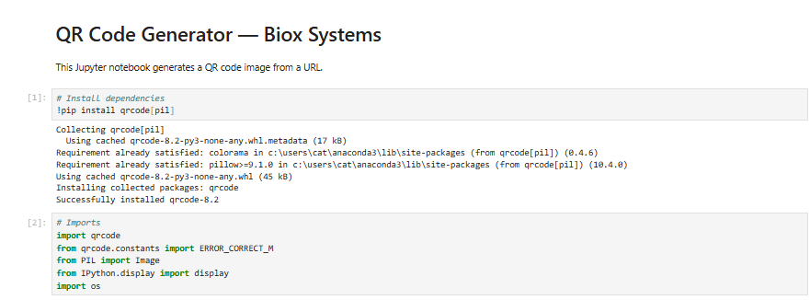

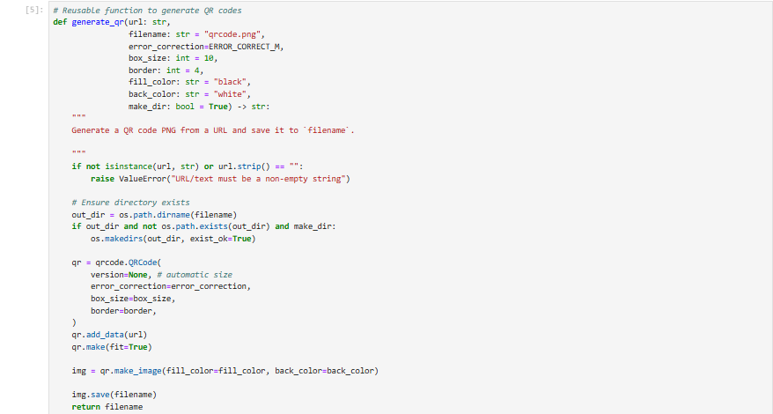

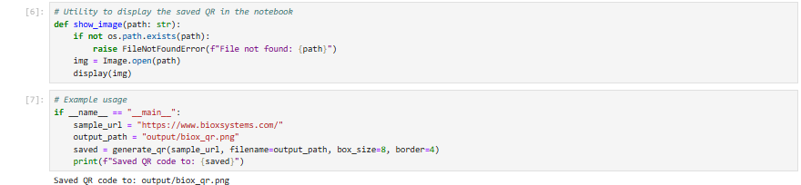

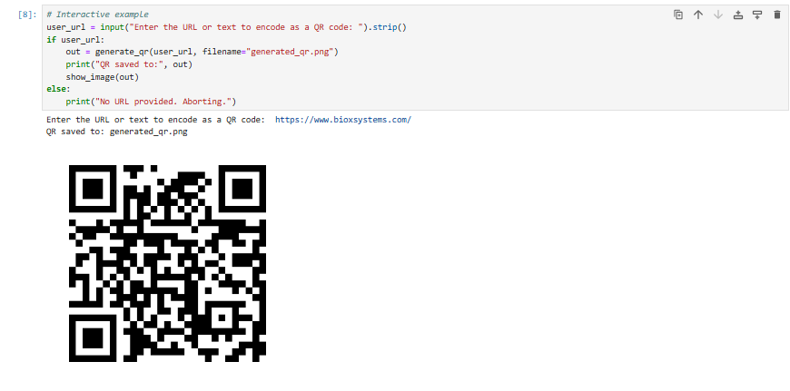

**Output 1**

Saved QR code to: output/biox\_qr.png

**Output 2**

Enter the URL or text to encode as a QR code: [https://www.bioxsystems.com/](https://www.bioxsystems.com/" \t "_blank)

QR saved to: generated\_qr.png

****